Project Title
Centralised College Database Management System

Project submitted to

SRM University – AP , Andhra Pradesh

For the partial fulfilment of the requirements to award the degree of

Bachelor of Technology

In

Computer Science and Engineering


School of Engineering and Sciences

Submitted by

Sreeja.N-AP24110010902

Under the Guidance of

Dr. Deepthi K C Kakumani

SRM University-AP

Neerukonda,

Mangalagiri, Guntur

Andhra Pradesh

522240

[April-2026]

1. Identification of Project

Project Title: Centralised College Database Management System

The Centralised College Database Management System is designed to store and manage academic and administrative information of a college in a structured manner. The system maintains details about departments, faculty members, students, courses, enrolments, attendance records, and examination results. The database helps in organising data efficiently and reduces manual work by maintaining all information in one centralised system. The project is implemented using SQL and follows relational database concepts such as entities, relationships, primary keys, and foreign keys.

2. Project Background

In educational institutions, a large amount of information is generated every day related to students, teachers, courses, and academic performance. Traditionally, this information was stored manually in registers or separate files, which made data handling difficult and time consuming. Manual systems often lead to problems such as duplication of data, data inconsistency, and difficulty in updating records. It also becomes difficult to retrieve information quickly when required.
With the advancement of technology, database systems are used to store and manage large amounts of data efficiently. A Database Management System allows data to be stored in tables and establishes relationships between them. This helps to maintain accuracy, consistency, and security of data. The Centralised College Database Management System is designed to solve the problems of manual record keeping by providing a structured way to store academic data. It ensures that information about students, faculty, courses, attendance, and results can be accessed easily and updated without errors.
Using DBMS concepts like ER diagrams, primary keys, foreign keys, and normalisation, the system ensures proper relationships between tables and maintains data integrity. The database structure helps avoid repeated data and makes it easier to perform operations like inserting, updating, and retrieving information.
The main aim of this project is to design a structured database that simplifies college data management and demonstrates the practical use of database concepts.

3. Description of the Project

The Centralised College Database Management System is developed to manage academic information in an organised and efficient way. The system consists of multiple related tables that store different types of data required in a college. The database maintains information about departments, faculty members, students, courses offered, enrolment details, attendance records, and examination results. Each entity is connected through relationships to ensure data consistency and integrity.
The Department table stores the details of different departments available in the college along with the head of department. The Faculty table stores information about teachers including their personal details, designation, and the department they belong to. The Student table contains student information such as name, email, phone number, and enrolment year. Each student belongs to a specific department.
The Course table stores information about subjects offered by the college and identifies which faculty teaches a particular course. Students enrol in courses, and this information is stored in the Enrolment table. The Attendance table keeps track of whether students are present or absent for each course on specific dates. The Result table stores the marks and grades obtained by students in different courses and semesters.
The project demonstrates how data can be structured into tables and connected using keys. Primary keys uniquely identify each record, while foreign keys create relationships between tables. This system helps in easy retrieval of information using SQL queries and ensures that data remains accurate and consistent. The project can be further extended to include additional features such as timetable management, fee details, and library records.

4. Entity-Relationship (ER) Diagram

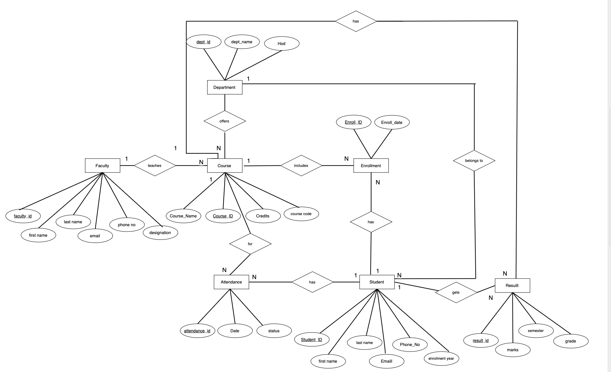

5. Description of ER Diagram

The ER diagram of the Centralized College Database Management System shows how different entities are related to each other. The Department entity represents academic departments in the college. Each department has a unique department ID and contains attributes such as department name and head of department. A department can offer multiple courses and can have many students and faculty members.
The Faculty entity represents teachers working in the college. Each faculty member belongs to a specific department and teaches one or more courses. The relationship between Faculty and Course is one-to-many because one faculty member can teach multiple courses.
The Student entity represents students studying in the college. Each student belongs to a department and can enroll in multiple courses. The Enrollment entity is used to store the relationship between Student and Course because one student can enroll in many courses and one course can have many students. This creates a many-to-many relationship which is resolved using the Enrollment table.
The Attendance entity records the attendance status of students in different courses. It stores whether a student is present or absent on a specific date. The Result entity stores marks and grades obtained by students in different courses and semesters. Each result is associated with both student and course, ensuring that performance can be tracked accurately.
Overall, the ER diagram clearly represents how academic information is organized in the database and shows the relationships between different entities.

6. Conversion of ER Diagram into Tables

The ER diagram is converted into relational tables by transforming each entity into a table and each attribute into a column. Primary keys are selected to uniquely identify each record in a table, and foreign keys are used to establish relationships between tables. These relationships ensure data consistency and maintain referential integrity within the database. The conversion process follows relational database design principles so that redundancy is minimised and data is stored efficiently.

6.1. DEPARTMENT → Department Table
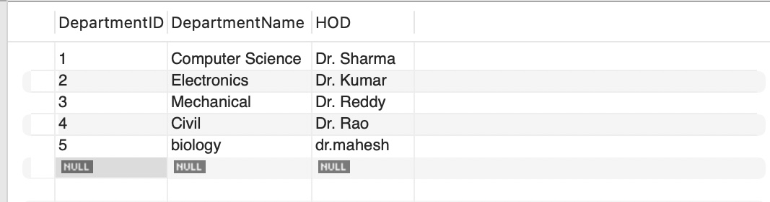
The Department entity is converted into the Department table. Each department is uniquely identified using the primary key DepartmentID. The table stores the department name and the Head of Department (HOD). This table acts as a parent table for Student, Faculty, and Course tables.

6.2. FACULTY → Faculty Table
The Faculty entity is converted into the Faculty table. Each faculty member is uniquely identified using FacultyID as the primary key. The DepartmentID attribute is used as a foreign key to establish the relationship between Faculty and Department. This shows that each faculty member belongs to one department.
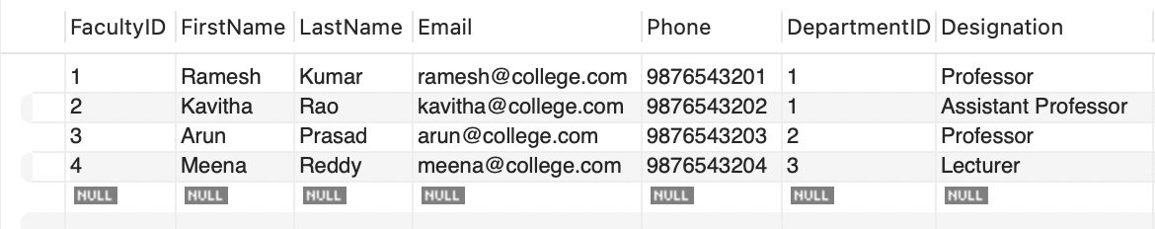

6.3. STUDENT → Student Table
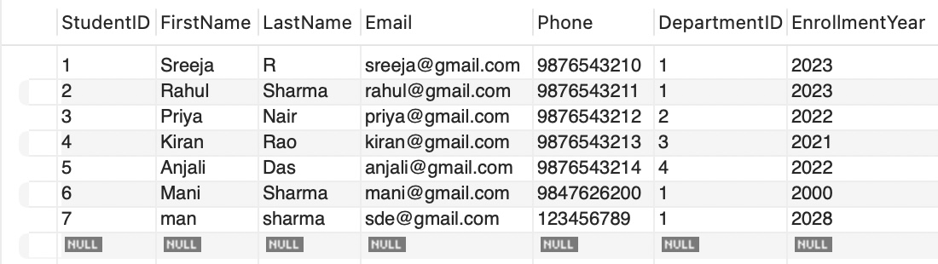
The Student entity is converted into the Student table. Each student is uniquely identified using StudentID as the primary key. The DepartmentID attribute acts as a foreign key linking students to their respective departments. This shows that each student belongs to a particular department.

6.4. COURSE → Course Table
The Course entity is converted into the Course table. Each course is uniquely identified using CourseID as the primary key. The DepartmentID foreign key shows which department offers the course. The FacultyID foreign key indicates which faculty member teaches the course. This establishes relationships between Course, Department, and Faculty.

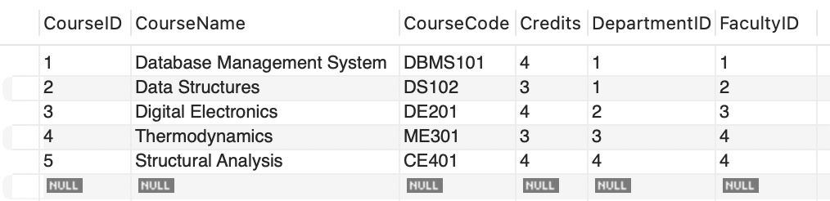
6.5. ENROLLMENT → Enrollment Table
The relationship between Student and Course is many-to-many because one student can enroll in multiple courses and one course can have many students. To resolve this relationship, the Enrollment entity is converted into the Enrollment table. The primary key is EnrollmentID. The table includes StudentID and CourseID as foreign keys to link students with courses.

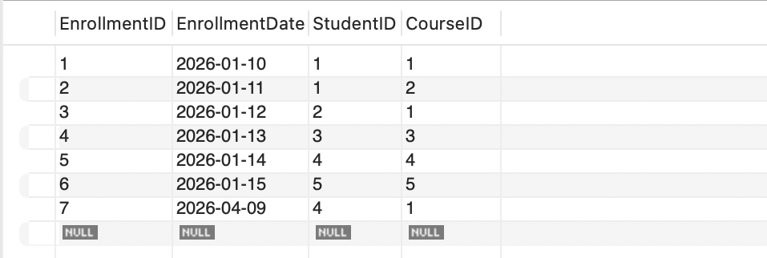
6.6. ATTENDANCE → Attendance Table
The Attendance entity is converted into the Attendance table. Each attendance record is uniquely identified using AttendanceID as the primary key. The table stores attendance status and date. The StudentID and CourseID attributes act as foreign keys linking attendance records to the respective student and course.

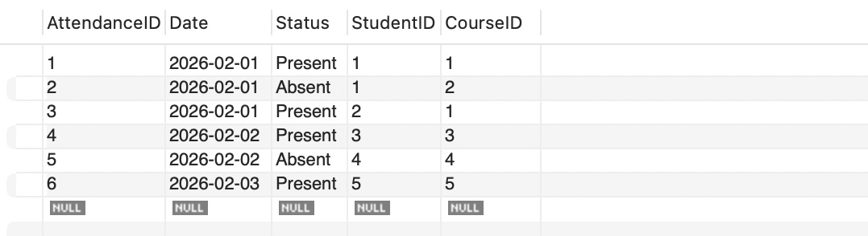
6.7. RESULT → Result Table

The Result entity is converted into the Result table. Each result record is uniquely identified using ResultID as the primary key. The table stores marks, grade, and semester information. The StudentID foreign key links the result to the student, and the CourseID foreign key links the result to the course. This allows tracking academic performance of students for each course.

7. Description of Tables
Below is the detailed schema outlining the exact structure, data types, and constraints of the tables derived from the ER Diagram.
7.1. DEPARTMENT
Stores information about academic departments available in the institution.
DepartmentID (PK): INT, Auto-increment.
Unique identifier for each department.
DepartmentName: VARCHAR, Name of the department (e.g., Computer Science, Electronics).
HOD: VARCHAR, Name of the Head of Department responsible for managing the department.

7.2. FACULTY
Stores professional and contact details of teaching staff working in the institution.
FacultyID (PK): INT, Auto-increment.
Unique identifier for each faculty member.
FirstName: VARCHAR, Faculty member's given name.
LastName: VARCHAR, Faculty member's surname.
Email: VARCHAR, Official email address of the faculty member.
Phone: VARCHAR, Contact telephone number.
DepartmentID (FK): INT, References DEPARTMENT(DepartmentID).
Indicates the department to which the faculty belongs.
Designation: VARCHAR, Academic role or job title (e.g., Professor, Lecturer).

7.3. STUDENT
Stores academic and personal information of students enrolled in the college.
StudentID (PK): INT, Auto-increment.
Unique identifier for each student.
FirstName: VARCHAR, Student's given name.
LastName: VARCHAR, Student's surname.
Email: VARCHAR, Student's email address.
Phone: VARCHAR, Student's contact number.
DepartmentID (FK): INT, References DEPARTMENT(DepartmentID).
Indicates the department in which the student is enrolled.
EnrollmentYear: INT, Year in which the student joined the institution.

7.4. COURSE
Stores details of academic subjects offered by the departments.
CourseID (PK): INT, Auto-increment.
Unique identifier for each course.
CourseName: VARCHAR, Name of the subject (e.g., Database Management System).
CourseCode: VARCHAR, Unique code assigned to the course.
Credits: INT, Credit value assigned to the course.
DepartmentID (FK): INT, References DEPARTMENT(DepartmentID).
Indicates which department offers the course.
FacultyID (FK): INT, References FACULTY(FacultyID).
Indicates which faculty teaches the course.

7.5. ENROLLMENT
Acts as a junction table that records which students are registered for which courses.
EnrollmentID (PK): INT, Auto-increment.
Unique identifier for each enrollment record.
EnrollmentDate: DATE, Date on which the student enrolled in the course.
StudentID (FK): INT, References STUDENT(StudentID).
Identifies the student who enrolled in the course.
CourseID (FK): INT, References COURSE(CourseID).
Identifies the course in which the student enrolled.

7.6. ATTENDANCE
Stores attendance records of students for each course session.
AttendanceID (PK): INT, Auto-increment.
Unique identifier for each attendance record.
Date: DATE, Date on which attendance is recorded.
Status: VARCHAR, Attendance state (e.g., Present, Absent).
StudentID (FK): INT, References STUDENT(StudentID).
Indicates which student's attendance is recorded.
CourseID (FK): INT, References COURSE(CourseID).
Indicates for which course attendance is recorded.

7.7. RESULT
Stores academic performance details of students in different courses and semesters.
ResultID (PK): INT, Auto-increment.
Unique identifier for each result entry.
Marks: INT, Numerical score obtained by the student.
Grade: VARCHAR, Grade assigned based on marks (e.g., A, B+).
Semester: INT, Academic semester in which the result was achieved.
StudentID (FK): INT, References STUDENT(StudentID).
Indicates the student to whom the result belongs.
CourseID (FK): INT, References COURSE(CourseID).
Indicates the course for which the result is recorded.

